

**Hale School**

**YEAR 11 SEMESTER 1 EXAMINATION 2018**

Write your name below:

__________________________________________

_______________________________________________

**ATAR ECONOMICS**

**Unit 1**

TIME ALLOWED FOR THIS PAPER:

Reading time before commencing: Ten minutes

Working time for paper: Three hours

|  |  |
| --- | --- |
| **For Examiners only** | |
| Section 1 |  |
| Section 2 |  |
| Section 3 |  |
| Total |  |

**Materials required/recommended for this paper**

**To be provided by the supervisor:**

This Question/Answer Booklet

Multiple-choice Answer Sheet

***To be provided by the candidate:***

Standard items: pens, pencils, eraser, correction fluid, ruler, highlighters

Special items: non-programmable calculators satisfying the conditions set by the Curriculum Council for this course.

**Important note to candidates**

No other items may be taken into the examination room. It is your responsibility to ensure that you do not have any unauthorised notes or other items of a non‑personal nature in the examination room. If you have any unauthorised material with you, hand it to the supervisor before reading any further.

**Structure of this paper**

|  |  |  |  |  |
| --- | --- | --- | --- | --- |
| Section | Number of questions available | Number of questions to be answered | Suggested working time  (minutes) | Marks available |
| Section One:  Multiple-choice | 24 | 24 | 35 | 24 |
| Section Two:  Data interpretation/Short response | 3 | 3 | 65 | 36 |
| Section Three:  Extended response | 4 | 2 | 80 | 40 |
|  |  |  |  | **100** |

**Instructions to candidates**

1. Answer the questions according to the following instructions.

Section One: Answer all questions on the separate Multiple-choice Answer Sheet provided. For each question shade the box to indicate your answer. Use only a B or 2B pencil to shade the boxes. If you make a mistake, completely erase your response and shade your new answer. Marks will not be deducted for incorrect answers. No marks will be given if more than one answer is completed for any question.

Sections Two and Three: Write answers in this Question/Answer Booklet.

2. You must be careful to confine your responses to the specific questions asked and to follow any instructions that are specific to a particular question.

3. Spare pages are included at the end of this booklet. They can be used for planning your responses and/or as additional space if required to continue an answer.

* + Planning: If you use the spare pages for planning, indicate this clearly at the top of the page.
  + Continuing an answer: If you need to use the space to continue an answer, indicate in the original answer space where the answer is continued, i.e. give the page number. Fill in the number of the question(s) that you are continuing to answer at the top of the page.

**Section 1: Multiple Choice 24% (24 Marks)**

This section has **24** questions. Answer **all** questions on the separate Multiple-choice answer sheet provided. For each question, shade the box to indicate your answer. If you make a mistake, place a cross through that square, then shade your new answer. Do not erase or use correction fluid/tape. Marks will not be deducted for incorrect answers. No marks will be given if more than one answer is completed for any question.

Suggested working time: 30 minutes

1. The economic problem faced by all societies is that:
2. there are unlimited productive resources to satisfy society’s unlimited needs and wants
3. the needs and wants of a small proportion of society cannot be fully satisfied
4. a significant percentage of the population live in poverty
5. there are limited productive resources to satisfy society’s unlimited needs and wants
6. The level of economic growth in Australia in May 2018, was 3.1%. This is an example of:
7. A value judgement
8. A normative statement
9. A positive statement
10. A statement that cannot be tested
11. Your family decides to spend $400 000 to buy a holiday home instead of investing it in the share market. The opportunity cost of this decision is:
12. the $400 000 it no longer has to spend
13. the future costs of paying for the upkeep of the holiday home
14. the $400 000 share portfolio and the potential net gain from this investment over time
15. the benefits gained by the family from having a holiday house
16. If a good is _________ and _________ it is a _________.
17. rival; non-excludable; private good
18. non-rival; excludable; public good
19. rival; excludable; public good
20. rival; excludable; private good
21. The opening up of a new iron ore mine in Western Australia will do which of the following to the world iron ore market?
    1. shift the supply curve to the right and bring about higher iron ore prices
    2. shift he supply curve to the left and bring about higher iron ore prices
    3. shift the supply curve to the left and bring about lower iron ore prices
    4. shift to supply curve to the right and bring about lower iron ore prices
22. Four changes affecting the supply of a good are listed below. Which would cause the supply curve to shift to the right?
23. an increase in its market price
24. an improvement in technology
25. a decrease in labour productivity
26. producers paying increased power charges as a result of the introduction of the carbon tax
27. When referring to elasticity of demand:
28. a low price elasticity of demand is consistent with a competitive market
29. businesses prefer a high elasticity of demand for their products
30. a low price elasticity of demand allows a business to increase prices and at the same time increase total revenue
31. the price elasticity of demand will tend to decrease when there are many substitute products for a good
32. The elasticity of supply for tomatoes is likely to increase if:
33. tomatoes are genetically modified to have a longer shelf life
34. there is a favourable media report about the health benefits of eating tomatoes
35. the cost of electricity used by tomato growers increases
36. producers have to pay higher transport costs to get their tomatoes to market
37. An industry has a market structure consisting of many buyers and few sellers, each with a large market share. This market structure is an example of:
38. monopoly
39. oligopoly
40. monopolistic competition
41. perfect competition
42. Consumer surplus can be defined as:
43. the maximum amount the consumer would pay for a good
44. the maximum amount a consumer would pay for a good minus the market price of the good
45. the amount of benefit a consumer obtains from a good divided by the market price of the good
46. the market price of the good minus the benefit of using the good
47. Which of the following is the most likely result from a successful advertising campaign for Ipads by Apple?
48. an increase in supply and the creation of a more elastic supply curve
49. an increase in supply and the creation of a more inelastic supply curve
50. an increase in demand and the creation of a more inelastic demand curve
51. an increase in demand and the creation of a more elastic supply curve
52. Student allowances increase from $150 to $165 per week. This leads to an average increase from 8 to 10 coffees consumed per week from a sample of students. This indicates that the income elasticity is
53. elastic with a coefficient of 3.4
54. inelastic with a coefficient of 1.8
55. elastic with a coefficient of 2.5
56. inelastic with a coefficient of 0.4
57. A change in relative prices:
58. sends a signal to producers as to where to direct resources
59. results in greater profits for producers
60. always increases demand for resources
61. has no effect on demand for resources
62. Consumer sovereignty means that decisions about resource allocation are directed by:
63. Producers
64. governments
65. consumers
66. all of the above
67. Which of the following policy initiatives may help to reduce market failure associated with positive externalities?
68. a reduction in the subsidy paid for solar panels
69. the introduction of a carbon tax
70. an increase in spending on vaccinations
71. increased powers given to the Australian Competition and Consumer Commission (ACCC) to investigate anti-competitive practices
72. The promoter of a theatre play discounted the price of admission by 30 per cent, which resulted in average attendances rising by 50 per cent. Based on this data, it could be concluded that there is an
73. elastic demand
74. inelastic demand
75. elastic supply
76. inelastic supply
77. An individual firm’s supply curve illustrates:
78. what will be sold in the market by the firm at a given point in time
79. what the producer is willing to sell at various prices at a given point in time
80. the market supply of any commodity offered for sale at any price
81. a combination of points on a supply curve that are indirectly related
82. Roses are more expensive on Valentine's Day than at other times of the year, yet sales of roses are highest on that day. How does economic theory account for this?
83. People buying roses on valentine’s day have elastic demand
84. Roses are not subject to the law of demand
85. Suppliers decrease the supply of roses to increase the price
86. An increase in demand increases the market clearing price of roses
87. In a competitive market, overproduction implies that for the last unit of the good produced
88. marginal benefit equals marginal cost.
89. marginal benefit exceeds marginal cost
90. marginal cost exceeds marginal benefit
91. he deadweight loss is zero
92. The diagram on the right represents the market for vaccinations. Vaccinations are considered a benefit to society, and the diagram shows both the private benefit and the social benefit from vaccinations. The socially optimum equilibrium price is _____ and the social optimum equilibrium quantity is _____ .
93. 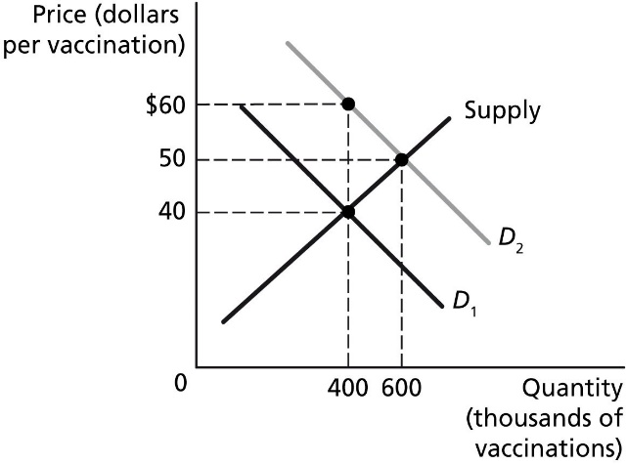$40; 400,000
94. $50; 600,000
95. $60; 400,000
96. $60; > 600,000
97. Suppose that milk producers expect that the price of milk is going to fall next month. This would cause
98. a decrease in the supply of milk today
99. an increase in the supply of milk today
100. an increase in the demand for milk today
101. the selling price of milk to rise today
102. A firm invests in a new, environmentally sustainable method for recycling used aluminium soft drink cans. Which of the following best describes the likely economic outcome that will result from the innovation?
103. a positive externality and a reduction in social cost
104. a negative externality and an increase in social cost
105. a positive externality and a reduction in social benefits
106. a negative externality and an increase in social benefits
107. Which one of the following will have a different effect on demand for new cars compared to the others?
108. an increase in motor registration fees
109. a decrease in household incomes
110. a fall in average hours worked by Australians
111. a decrease in fuel costs
112. The demand curve for butter will shift to the left if:
113. its price rises
114. the price of margarine decreases
115. the price of bread falls
116. there is an increase in population

__________________________________________________________________________________

***End of Section One***

**Section Two: Data interpretation/Short response 36% (36 Marks)**

This section contains **three (3)** questions. Answer **all** questions. Write your answers in the

spaces provided.

Additional working space pages at the end of this Question/Answer booklet are for planning or continuing an answer. If you use these pages, indicate at the original answer, the page number it is planned/continued on and write the question number being planned/continued on the additional working space page.

Suggested working time: 70 minutes.

_________________________________________________________________________________

**Question 25 (12 marks)**

**Demand & Supply Schedule for Bananas**

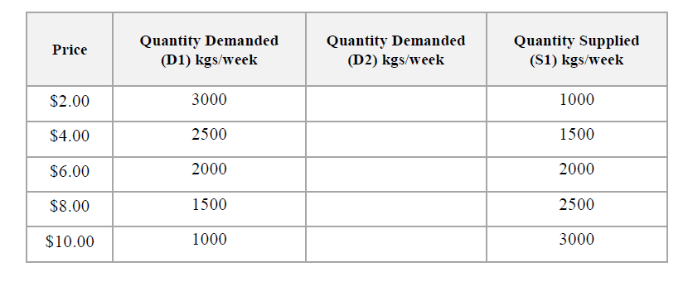

1. Define Demand. (1 mark)

______________________________________________________________________________

______________________________________________________________________________

______________________________________________________________________________

1. Construct a demand curve (D1) and supply curve (S1) based on the demand and supply schedule for bananas. (2 marks)

|  |  |  |  |  |  |  |  |  |  |  |  |  |  |  |  |
| --- | --- | --- | --- | --- | --- | --- | --- | --- | --- | --- | --- | --- | --- | --- | --- |
|  |  |  |  |  |  |  |  |  |  |  |  |  |  |  |  |
|  |  |  |  |  |  |  |  |  |  |  |  |  |  |  |  |
|  |  |  |  |  |  |  |  |  |  |  |  |  |  |  |  |
|  |  |  |  |  |  |  |  |  |  |  |  |  |  |  |  |
|  |  |  |  |  |  |  |  |  |  |  |  |  |  |  |  |
|  |  |  |  |  |  |  |  |  |  |  |  |  |  |  |  |
|  |  |  |  |  |  |  |  |  |  |  |  |  |  |  |  |
|  |  |  |  |  |  |  |  |  |  |  |  |  |  |  |  |
|  |  |  |  |  |  |  |  |  |  |  |  |  |  |  |  |
|  |  |  |  |  |  |  |  |  |  |  |  |  |  |  |  |
|  |  |  |  |  |  |  |  |  |  |  |  |  |  |  |  |
|  |  |  |  |  |  |  |  |  |  |  |  |  |  |  |  |
|  |  |  |  |  |  |  |  |  |  |  |  |  |  |  |  |
|  |  |  |  |  |  |  |  |  |  |  |  |  |  |  |  |

1. If the price fell below the market equilibrium to $2.00 per kilogram, explain the impact this would have on the market. (2 marks)

______________________________________________________________________________

______________________________________________________________________________

______________________________________________________________________________

______________________________________________________________________________

______________________________________________________________________________

1. Calculate the price elasticity of supply for bananas if the price increased from $8.00 per kg to $10.00 per kilogram. Explain your answer. (2 marks)

______________________________________________________________________________

______________________________________________________________________________

______________________________________________________________________________

______________________________________________________________________________

______________________________________________________________________________

1. Calculate the cross elasticity of demand if the price of bananas increases from $8.00 per kg to $10.00 per kg and results in the demand for oranges increasing from 3000 kg to 4000 kg. Explain your answer. (2 marks)

______________________________________________________________________________

______________________________________________________________________________

______________________________________________________________________________

______________________________________________________________________________

______________________________________________________________________________

1. Complete the demand and supply schedule by adding 500kg to the original quantity demanded at each price level in column D2. Plot this new demand curve onto the graph indicating the new market equilibrium. (1 mark)
2. Discuss two (2) possible reasons for this increase in demand from D1 to D2. (2 marks)

______________________________________________________________________________

______________________________________________________________________________

______________________________________________________________________________

______________________________________________________________________________

______________________________________________________________________________

______________________________________________________________________________

______________________________________________________________________________

______________________________________________________________________________

______________________________________________________________________________

______________________________________________________________________________

**Question 26 (12 marks)**

**Price Floor for Dairy Farmers**

[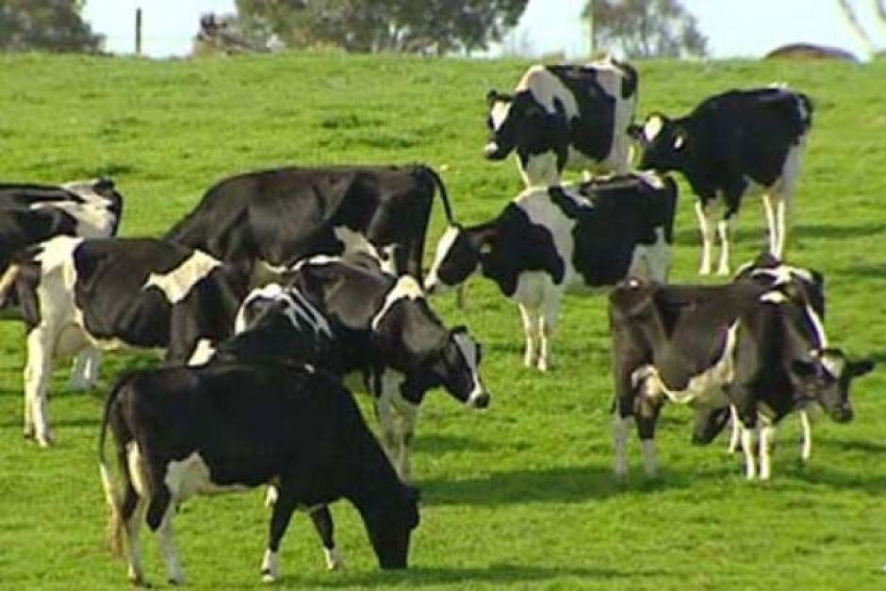](https://www.google.com.au/url?sa=i&rct=j&q=&esrc=s&source=images&cd=&cad=rja&uact=8&ved=2ahUKEwiJnqa4gtDbAhWGVLwKHf31ABsQjRx6BAgBEAU&url=http://www.abc.net.au/news/2013-01-08/dairy-farmers-contemplate-future/4455998&psig=AOvVaw2WA9bEmI99Nsklr0pwawJF&ust=1528957961899127)

Australian dairy farmers say they will struggle to break even this year with the major milk processors unveiling prices below the cost of production. Historically low milk prices are creating a crisis for our farmers and dairy communities, and Parliament needs to fix this problem now. A minimum price for dairy farmers will ensure that our farmers don’t go bankrupt every time prices drop,” Gillibrand says.

ABC News 2016

1. Explain the difference between a price floor and a price ceiling. (2 marks)

______________________________________________________________________________

______________________________________________________________________________

______________________________________________________________________________

______________________________________________________________________________

______________________________________________________________________________

1. Explain the effect of a price floor on the dairy market and use a diagram to show what happens to the quantity supplied and quantity demanded. (3 marks)

______________________________________________________________________________

______________________________________________________________________________

______________________________________________________________________________

______________________________________________________________________________

______________________________________________________________________________

1. Who will benefit from the price floor and who will lose? Explain how the price floor will affect market efficiency referring to the changes to consumer and producer surplus. (5 marks)

______________________________________________________________________________

______________________________________________________________________________

______________________________________________________________________________

______________________________________________________________________________

______________________________________________________________________________

______________________________________________________________________________

______________________________________________________________________________

______________________________________________________________________________

______________________________________________________________________________

______________________________________________________________________________

______________________________________________________________________________

______________________________________________________________________________

______________________________________________________________________________

______________________________________________________________________________

______________________________________________________________________________

______________________________________________________________________________

______________________________________________________________________________

______________________________________________________________________________

______________________________________________________________________________

1. At the price of $2 per litre of milk, 1 million litres of milk are sold and total revenue for producers is $2,000,000. When a price floor is introduced, the new quantity demanded is 970,000 litres and total revenue is $2,134,000. What is the price floor for a litre of milk? Is milk elastic or inelastic? (2 marks)

______________________________________________________________________________

______________________________________________________________________________

______________________________________________________________________________

______________________________________________________________________________

______________________________________________________________________________

______________________________________________________________________________

**Question 27 (12 marks)**

China is paying the price of its enormous economic growth with increasing pollution because it still relies heavily on coal-fired power. But the price of that growth in terms of pollution is earning increasing criticism, especially from Chinese citizens at home.  
  
There are more than five million cars on the road in the Chinese capital. They're seen as a measure of affluence and modernity. Yet they deliver a terrible toll in terms of air quality deterioration. This year Beijing's pollution has hit record levels, thanks in no small measure to the motor vehicle. Everybody knows about the connection yet the cars keep coming. But there are other major contributors to this enormous problem which is really a regional rather than city challenge. Yet despite its vast reserves, this country is so dependent on coal that it imports even more of it from Australia. Coal for electricity, coal for heating and coal for heavy industrial production. China consumes nearly half of the world's supply, and if it were not for an enormous rollout of renewable energies like wind power, it would be consuming even more.  
  
The choices China faces juggling pollution and economic growth are frankly pretty tough. Gone are the days of automatic praise over the mere speed of development. Now some people here are talking about toxic growth and wondering whether it's all really worth it.  
  
Greenpeace says it'd be happy enough if growth could be maintained at existing high levels. It says that this would at least leave room to find some solutions. But what they fear is further escalations. The new government in Beijing also says it wants to rein in pollution. Yet its stated priorities are clear: economic growth remains number one. And it's obvious to everyone that in China as it stands, faster economic growth and cleaner air are simply not compatible.

1. Define externalities. (1 mark)

______________________________________________________________________________

______________________________________________________________________________

_____________________________________________________________________________

1. What are the negative external effects of a high level of economic growth in China? (2 marks)

______________________________________________________________________________

______________________________________________________________________________

______________________________________________________________________________

______________________________________________________________________________

______________________________________________________________________________

1. With the aid of a diagram, explain the implications for Chinese car manufactures, consumers and the government of including negative externalities into the cost of production through the use of pollution taxes. (6 marks)

______________________________________________________________________________

______________________________________________________________________________

______________________________________________________________________________

______________________________________________________________________________

______________________________________________________________________________

______________________________________________________________________________

______________________________________________________________________________

______________________________________________________________________________

______________________________________________________________________________

______________________________________________________________________________

______________________________________________________________________________

______________________________________________________________________________

______________________________________________________________________________

______________________________________________________________________________

______________________________________________________________________________

______________________________________________________________________________

______________________________________________________________________________

______________________________________________________________________________

______________________________________________________________________________

______________________________________________________________________________

______________________________________________________________________________

1. The government in Beijing says it wants to get control of pollution. Besides production taxes, what other solutions would help to minimize the externalities caused by pollution. (3 marks)

______________________________________________________________________________

______________________________________________________________________________

______________________________________________________________________________

______________________________________________________________________________

______________________________________________________________________________

______________________________________________________________________________

______________________________________________________________________________

______________________________________________________________________________

______________________________________________________________________________

______________________________________________________________________________

______________________________________________________________________________

______________________________________________________________________________

***End of Section two***

**Section Three: Extended response 40% (40 Marks)**

This section contains four (4) questions. Answer two (2) questions. Write your answers in the lined pages provided and number your answers clearly.

Additional working space pages at the end of this Question/Answer booklet are for planning or continuing an answer. If you use these pages, indicate at the original answer, the page number it is planned/continued on and write the question number being planned/continued on the additional working space page.

Suggested working time: 80 minutes.

________________________________________________________________________________

Question 28

1. What are the characteristics of a market economy? (6 marks)
2. What is meant by the term equilibrium? (4 marks)
3. Use demand and supply analysis to explain the concept of a market shortage. How does the price mechanism correct a shortage in the market? (10 marks)

________________________________________________________________________________

Question 29

1. Explain the difference between a competitive and non competitive market. (4 marks)
2. Explain the role of the Australian Competition and Consumer Commission (ACCC) in promoting competition in the economy. (6 marks)
3. With the aid of examples, describe solutions available to governments to correct different types of market failure. (10 marks)

________________________________________________________________________________ Question 30

1. Explain the meaning of price elasticity of supply and, using a diagram(s), distinguish between price elastic and price inelastic supply. (6 marks)
2. Discuss three factors that would cause the demand for a good to be relatively price elastic.

(6 marks)

1. Explain how economists use the concept of elasticity to distinguish between normal and inferior goods and between substitutes and complements. (8 marks)

________________________________________________________________________________

Question 31

1. What is meant by market concentration? Explain, with the aid of a diagram and examples, the impact of companies having too much market power? (10 marks)
2. The Australian Government plans to introduce a tariff on steel. With the aid of a demand and supply diagram explain the likely impact that a tariff on steel will have on consumers, producers and the government. (10 marks)

***End of questions***